Data Technician
Workbook
Week 3
Databases and SQL

Name:
Course Date:
Table of contents
Day 1: Task 1 3
Breakout Room Activity: Designing a Relational Database (45 min) 3
Business Scenario 3
Day 1: Task 2 6
Day 2: Task 1 8
Day 3: Task 1 11
Day 3: Task 2 13
Day 4: Task 1: SQL Practical 15
Additional Resources 19
Additional Information 19
Course Notes 20

Day 1: Task 1

Breakout Room Activity: Designing a Relational Database (45 min)

Business Scenario
You have been hired as a junior data technician for a small training company called SkillUp Academy. The company currently stores all its data in a single spreadsheet, which is causing duplicate information, data inconsistencies, and severe difficulty updating records.
Your team's task is to collaboratively design a simple relational database that organizes this data more effectively.
⏱️ Part 1: The Team Huddle (10 Mins)
Task 1: Database Purpose Discuss the scenario as a team. Work together to write a brief, 2-to-3-sentence "Elevator Pitch" explaining the purpose of the new database.
✍️ Your team response must include: What the database will be used for, who will use it, and what type of data it will store.
Your Team's Purpose Statement:
As a Junior Data Technician at SkillUp Academy, I am designing a database to streamline the management of training programs and student records. The database will be used by administrators and instructors to track students, courses, enrolments, and instructor details, ensuring accurate data storage and efficient reporting.

Part 2: Identify Tables and Columns (15 Mins)
Task 2: Database Schema Blueprint Brainstorm the four main tables SkillUp Academy needs (e.g., the core entities they track). For each table, agree on a unique Primary Key and at least 3-4 essential columns.
Fill out the team blueprint below:
📋 Table 1: Student – Store information about learners enrolled at SkillUp Academy
- Primary Key: StudentID
- Columns:
  - FirstName
  - LastName
  - Email
  - Address
  - PostCode
  - PhoneNumber
  - DOB
📋 Table 2: Course
- Primary Key: CourseID
- Columns / Attributes:
  - CourseName
  - CourseDescription
  - Duration
  - StartDate
  - CourseFee
📋 Table 3: Instructors
- Primary Key: InstructorID
- Columns / Attributes:
  - FirstName
  - LastName
  - Email
  - SubjectArea
  - PhoneNumber
📋 Table 4: Enrolment
- Primary Key: EnrolmentID
- Columns:
  - StudentID (Foreign Key)
  - CourseID (Foreign Key)
  - EnrolmentDate
  - CompletionStatus
  - FinalGrade

Part 3: Define Relationships (10 Mins)
Task 3: Connecting the Data Discuss how your tables talk to each other. Identify at least two one-to-many relationships required to make this database function correctly.
- Relationship 1:
  - Table A: Student connects to Table B: Enrolments
  - Which column is the Foreign Key? StudentID (in the Enrolments table)
  - Why is this relationship needed? This relationship allows the database to track which courses each student has enrolled in. One student can have many enrolments, but each enrolment belongs to only one student.
- Relationship 2:
  - Table A: Courses connects to Table B: Enrolments
  - Which column is the Foreign Key? CoursesID (in the Enrolments table)
  - Why is this relationship needed? This relationship allows the database to track which students are enrolled in each course. One course can have many student enrolments, but each enrolment is linked to only one course.
• Students (1) → Many Enrolments
• Courses (1) → Many Enrolments
The Enrolments table acts as a link between Students and Courses, allowing SkillUp Academy to manage course registrations efficiently while avoiding duplicate data.

Day 1: Task 2

Choosing the Right Type of Database
Business Scenario
SkillUp Academy is planning to expand its systems.
In addition to structured course and learner data, the company now wants to store:
- Website click data
- User activity logs
- Feedback comments from learners
- Uploaded documents
They are unsure whether a relational database or a non-relational database would be more suitable for this data.
You have been asked to help explain the options.

Task 1: Compare Database Types
In your own words, explain the difference between:
- A relational database
- A non-relational (NoSQL) database
Your answer should include:
- How data is stored
- How structured the data is
- An example use case for each
✍️ Write in clear, simple language.

A relational database is a set of structured data tables with rows and columns. It is a fixed format for each record, used in some cases such as managing student, course, instructor, and enrolment records at Skill Academy. The tables are connected using keys, making it easy to organise and access related information.
For example,
StudentID | StudentName | CourseID
101 | Eloni Fuss | C001
102 | Matthew Lewis | C002

While a non-relational database format is unlike relational databases, the data does not need to follow a fixed structure and is flexible. It allows different records to be stored and used for different types of information, such as user activity logs, learner feedback, uploaded documents/files, and website click data.
For example,
1 User: Eloni Fuss
2 Activity: Viewed Course Page
3 Comment: Great course content!

Both relational Vs non-relational have different functionality. A relational database is best for SkillUp Academy's student, course, instructor, and enrolment data because this information is organised and structured. A non-relational database is better for website click data, activity logs, feedback comments, and uploaded documents because this data is more varied and flexible.

Task 2: Identify Suitable Data for a Non-Relational Database
From the scenario above, identify two types of data that would be better stored in a non-relational database.
Examples may include:
- User activity logs
- Feedback text
- Website events
For each type of data:
- State what the data is
- Explain why a non-relational database is suitable
✍️ Focus on flexibility, structure, and data format.
Two types of suitable data for a Non-Relational Database:
1. User Activity Logs

Data store user actions on the website, such as logging in, viewing courses, downloading materials, or completing lessons.

Why is a non-relational database suitable? Activity logs can be large and may contain different types of information for different actions.
A non-relational database can store this data in a flexible format without requiring every record to have the same structure. It is also well suited for handling large volumes of continuously growing data.

Example:
User: Eloni Fuss
Activity: Downloaded Course Material
Time: 10:15 AM

2. Learner Feedback Comments

It’s data that stored/recorded of written comments and feedback submitted by learners about courses and instructors.

Why is a non-relational database suitable? Feedback comments vary in length and content, making them less structured than table-based data.
A non-relational database can store text, ratings, attachments, and other feedback details in a flexible format. New fields can be added easily without changing the entire database structure.

Example:
Course: Data Analytics
Rating: 5
Comment: The course was very informative and easy to follow.

User activity logs and learner feedback comments are better stored in a non-relational database because they are flexible, may not follow a fixed structure, and can grow quickly over time.

Task 3: Justify Your Choice
Explain why this data would not be ideal for a traditional relational database.
Consider:
- Data structure
- Frequency of changes
- Volume of data
✍️ Use plain English — no advanced terminology required.
User activity logs aren't ideal for a traditional relational database because the data isn't always structured the same way. For example, a login event may contain different information from a course completion event or a file download event.

The data also changes frequently because new user activities are constantly being recorded. In a relational database, changing the structure to accommodate new activity types can be time-consuming and less flexible.

In addition, user activity logs are generated in large volumes every day. As the number of users grows, the amount of log data increases rapidly. A non-relational database is better suited to handling large amounts of continuously growing data while maintaining good performance.

Day 2: Task 1
You are a junior data analyst at Northwind Traders. Your manager has assigned you a series of real-world business tasks. For each scenario:
- Write an SQL query to solve the request. Write an SQL query to solve the request.
- Run the query in Supabase using the Northwind database.
- Paste your query in the box below each question as evidence of completion.

1.📘 Retrieve Full Customer Data
Your manager has asked you to export the full list of all customer details into a report.
Setup Northwind DB
You will need to sign up, create organization, a project and db tables on Supabase website.
You can find instructions here.
  - Supabase video tutorial: Supabase Tutorial
  - Supabase Instructions: Supabase for SQL
  - Create Tables Script: Create Northwind DB
Create Tables Northwind.txt – by selecting the SQL editor → run, and selecting run without RLS

➡️ Write a SQL query to retrieve all columns from the Customers table.
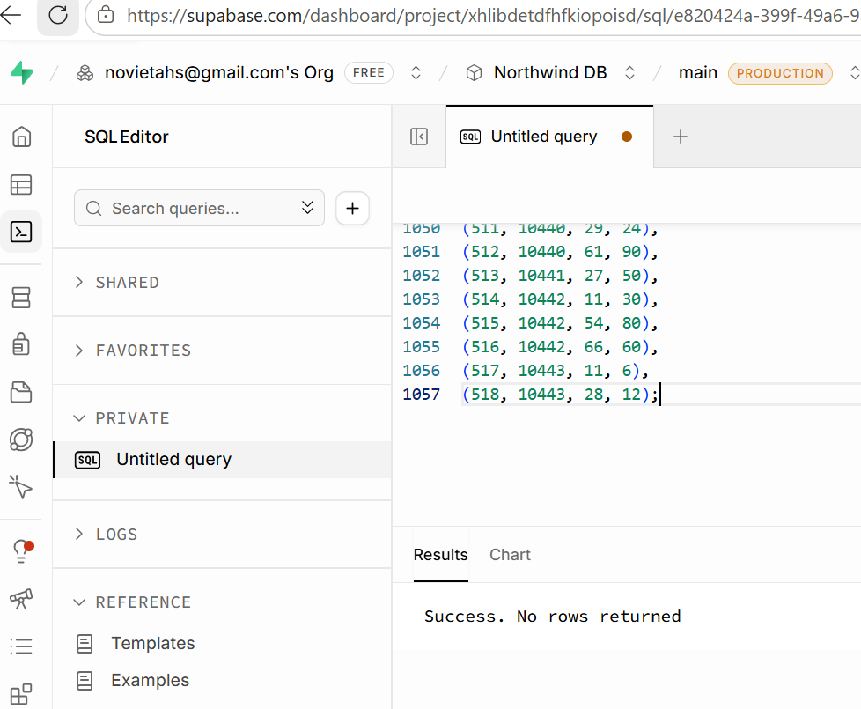
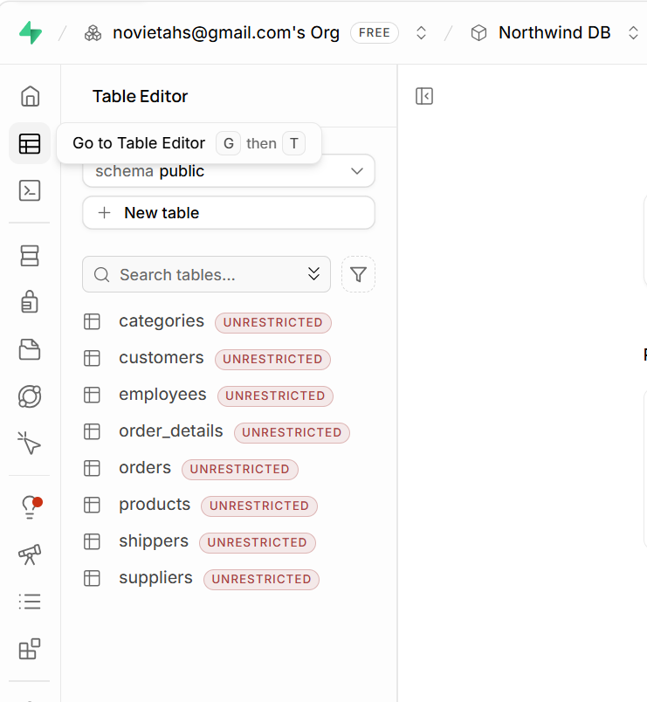

2.📘 Customer Names and Cities for Marketing
A marketing analyst is targeting a campaign based on customer names and their cities.
➡️ Write a SQL query to retrieve only the CustomerName and City columns from the Customers table.
SELECT CustomerName, City, Country
FROM Customers;
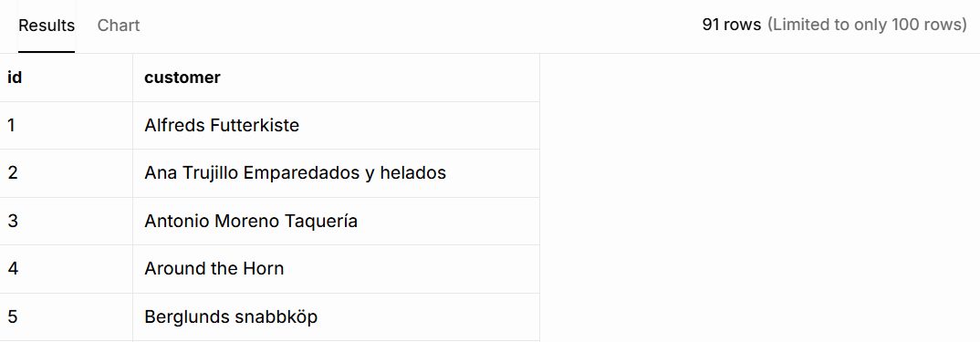

3. 📘 Unique Cities for Delivery Network Expansion
The logistics team wants to know all the different cities where customers are located (no duplicates).
➡️ Write a SQL query to retrieve distinct values from the City column in the Customers table.
SELECT DISTINCT City FROM Customers
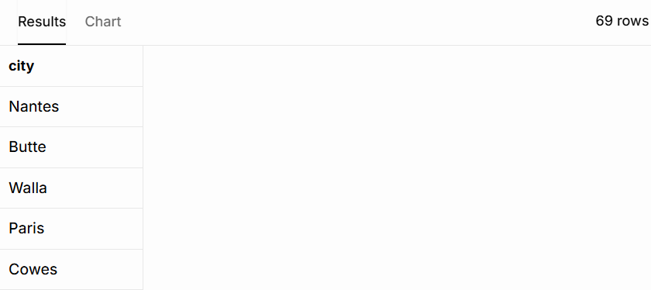

4.📘 High-Value Products Report
The product manager wants to analyse products priced over £50.
➡️ Write a SQL query to retrieve all columns from the Products table where the Price is greater than 50.
SELECT * FROM Products
WHERE Price > 50;
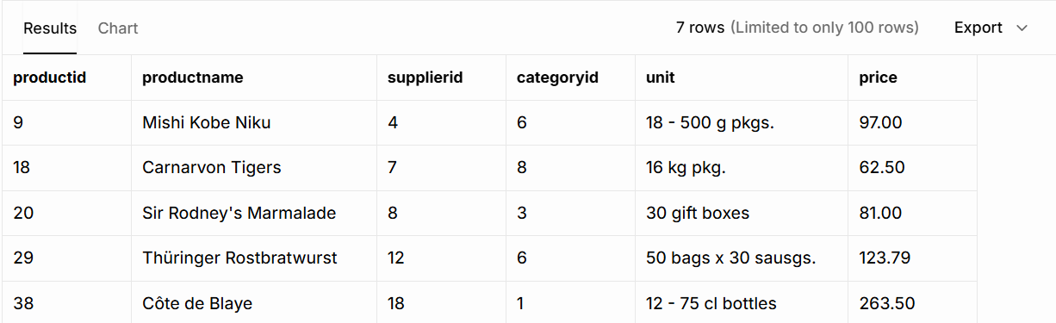

5.📘 International Customers Targeting (USA & UK)
The marketing team is preparing campaigns for customers in the USA and UK.
➡️ Write a SQL query to retrieve all columns from the Customers table where the Country is either 'USA' or 'UK'.
SELECT *
FROM Customers
WHERE Country IN ('USA', 'UK');
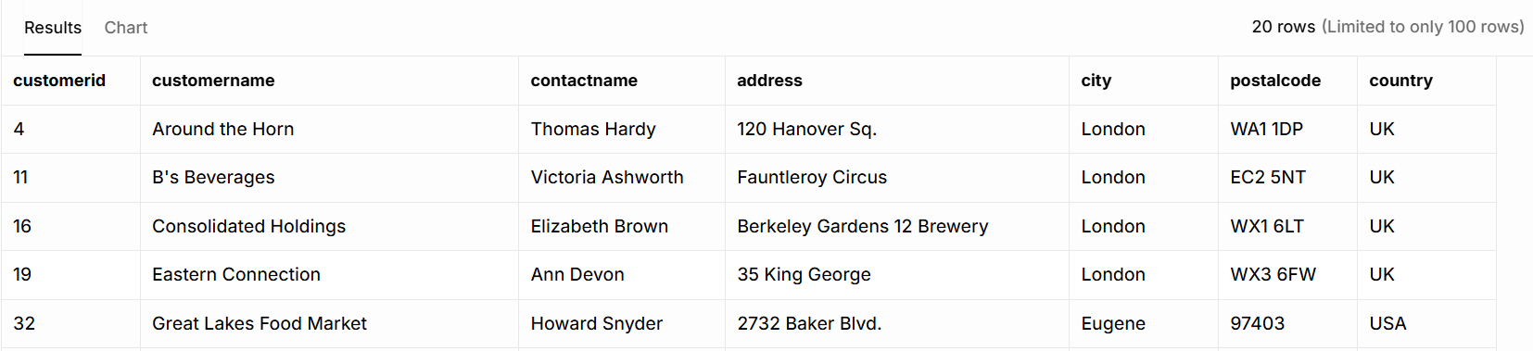

6.📘 Recent Orders Report
Your team needs to analyze the latest orders.
➡️ Write a SQL query to retrieve all columns from the Orders table, sorted by OrderDate in descending order.
SELECT *
FROM Orders
ORDER BY OrderDate DESC;
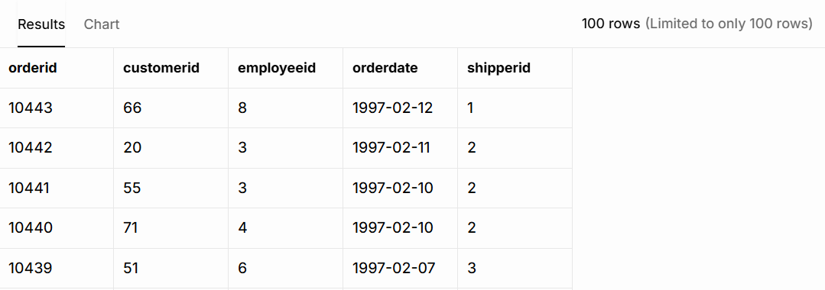

7.📘 Mid-Range Products Listing
You are preparing a product list for items priced between £20 and £50.
➡️ Write a SQL query to retrieve all columns from the Products table where the Price is between 20 and 50, ordered by descending Price.
SELECT *
FROM Products
WHERE Price BETWEEN 20 AND 50
ORDER BY Price DESC;
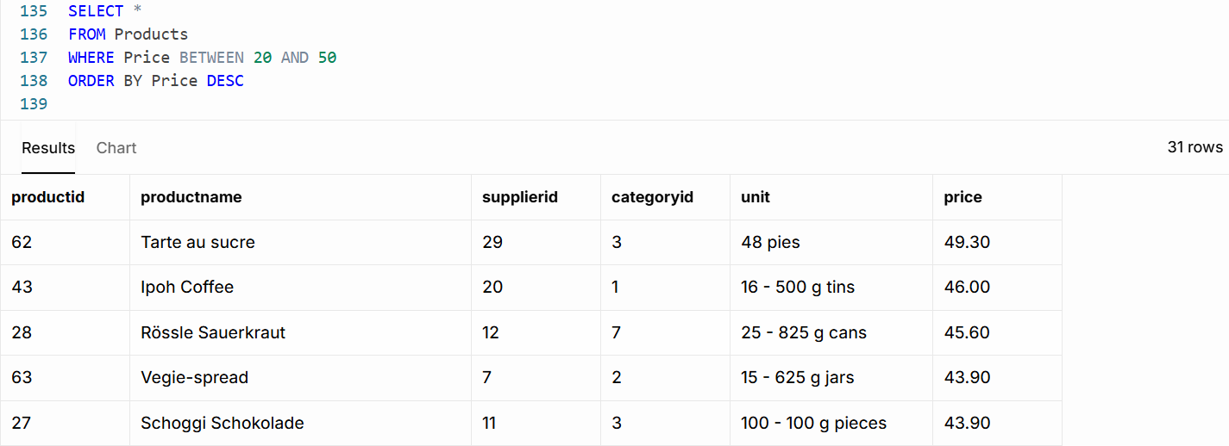

8.📘 Local Marketing in the US (Portland & Kirkland)
You’re focusing on customers from Portland and Kirkland in the USA.
➡️ Write a SQL query to retrieve all columns from the Customers table where the Country is 'USA' and City is either 'Portland' or 'Kirkland', ordered by ascending CustomerName.
SELECT *
FROM Customers
WHERE Country = 'USA'
AND City IN ('Portland', 'Kirkland')
ORDER BY CustomerName ASC;
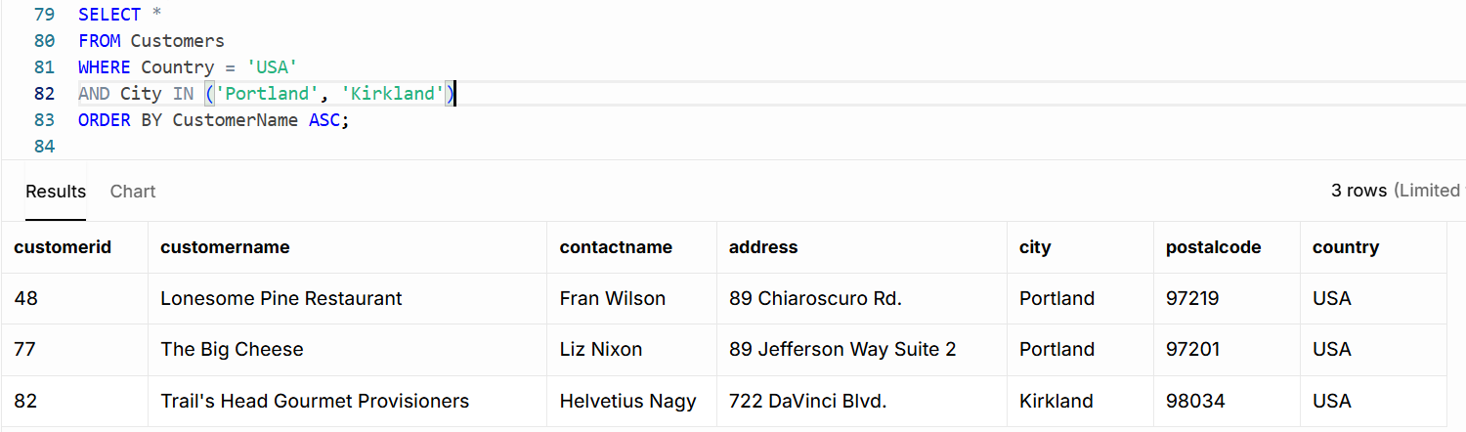

9. 📘 Customers from the UK or London
Prepare a list for promotional emails targeting customers from the UK or those based in London.
➡️ Write a SQL query to retrieve all columns from the Customers table where the Country is 'UK' or City is 'London', ordered by descending CustomerName.
SELECT *
FROM Customers
WHERE Country = 'UK' OR City = 'London'
ORDER BY CustomerName DESC;
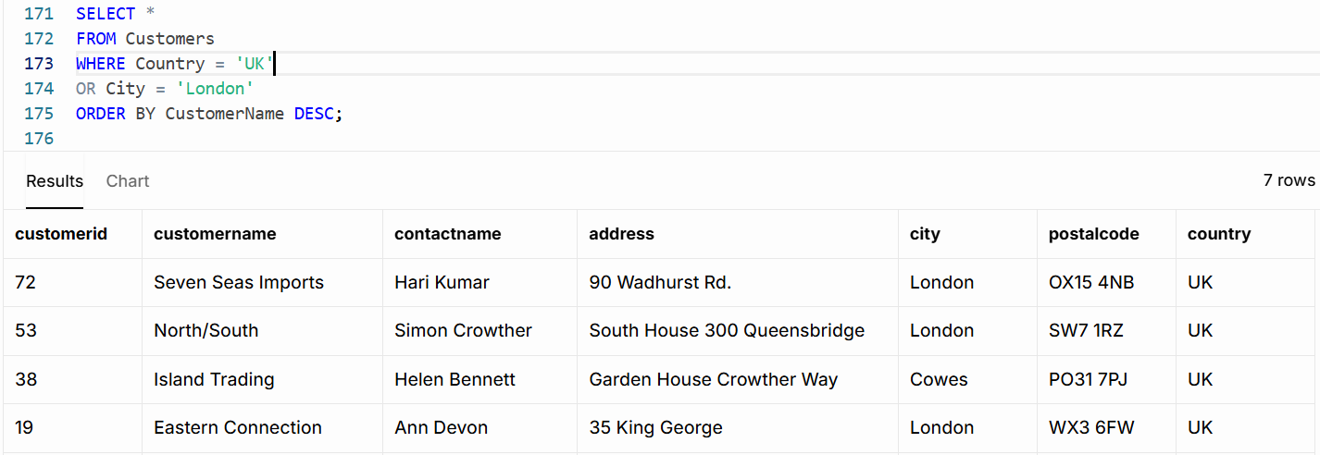

10.📘 Product Inventory for Selected Categories
The inventory team needs products from Category 1 or 2, sorted alphabetically.
➡️ Write a SQL query to retrieve all columns from the Products table where the CategoryID is 1 or 2, ordered by ascending ProductName.
SELECT *
FROM Products
WHERE CategoryID IN (1, 2)
ORDER BY ProductName ASC;
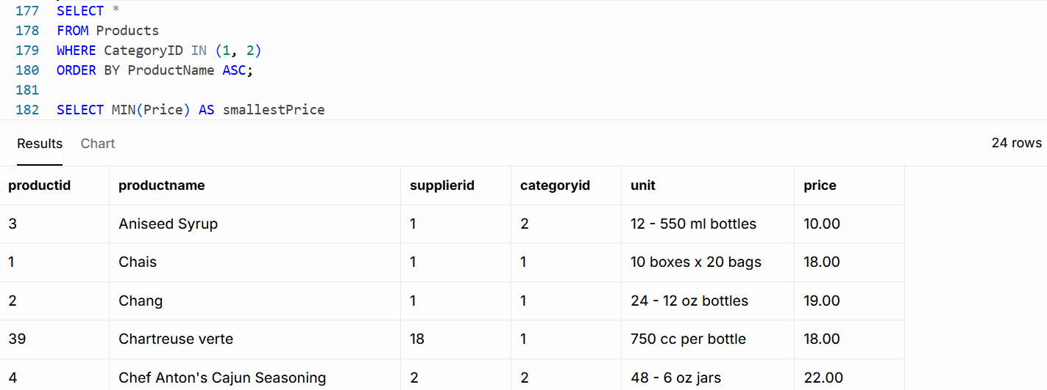

Day 3: Task 1
Scenario-Based Activity: Understanding SQL JOINs
Business Scenario
SkillUp Academy stores its data across several related tables, such as:
- Learners
- Courses
- Trainers
- Enrolments
To create reports (for example, seeing which learners are enrolled on which courses), the data team needs to combine data from multiple tables.
Different types of SQL JOINs are used depending on what information is needed.

Task 1: Explain JOIN Types (Plain English)
For each JOIN type below:
- Explain what the JOIN does in simple terms
- Explain when it would be used in a real scenario
You do not need to write SQL code unless instructed.
JOIN Types to Explain
- Inner Join
- Left Join
- Right Join
- Full Join
- Cross Join
✍️ Use short, clear explanations.
Inner Join
An Inner Join combines data from two tables and only shows records that match (and exist) in both tables. An inner join can be used (for example) in school databases that have a list of students and a list of course enrolments. An Inner Join would show only the students who are enrolled in a course.

Left Join
A Left Join shows all records from the first table and any matching records from the second table. If there is no match, the information from the second table is left blank. A left join can be used (for example) in employee databases where a company has a list of employees and a list of training records. A Left Join would show all employees, including those who have not completed any training.

Right Join
A Right Join shows all records from the second table and any matching records from the first table. If there is no match, the information from the first table is left blank. A right join can be used (for example) in employee databases where a company has a list of departments and a list of employees. A Right Join would show all departments, including those that currently have no employees.

Full Join
A Full Join shows all records from both tables. Matching records are combined, and non-matching records are still displayed with blank values where information is missing. A full join can be used (for example) when a company wants to compare its products and order details. A Full Join would show all products, including those that have never been ordered, and all order records, including any that might not have a matching product record.

Cross Join
A Cross Join combines every record from one table with every record from another table. It creates all possible combinations, such as planning scenarios, testing data, or generating lists of possible product-order pairings. A cross join can be used (for example) when a company wants to see every possible combination of products and orders. Each product would be paired with every order, regardless of whether that product was actually included in the order.

Task 2: Match JOINs to Data Scenarios
Below are example reporting needs at SkillUp Academy.
For each one:
- Identify which JOIN type would be most suitable
- Explain why

Example Scenarios
- Viewing only learners who are enrolled on a course
- Listing all courses, including those with no enrolments yet
- Showing all learners and all courses, even if they are not linked
- Creating all possible combinations of learners and courses for planning
- Comparing learners to other learners (e.g. same course, same city)
- Viewing enrolments even if some related data is missing
✍️ Explain your reasoning in plain English.
- Viewing only learners who are enrolled on a course
To show the above query, use an Inner Join, as it shows learners who are actually enrolled on a course. Learners without enrolments and courses without learners will not be included.
- Listing all courses, including those with no enrolments yet
For this, the most suitable JOIN type is Left Join.
A Left Join returns all records from the main table (Courses) and any matching enrolment records. Courses that have no enrolments will still appear in the results.
- Showing all learners and all courses, even if they are not linked
For the above query, the most suitable is Full Join. A Full Join returns all records from both tables. It shows learners who are not enrolled on any course and courses that do not yet have any learners.
- Creating all possible combinations of learners and courses for planning
For the above query, the most suitable is a Cross Join. A Cross Join creates every possible combination between two tables. Each learner is matched with every course, making it useful for planning, scheduling, or forecasting scenarios.
- Comparing learners to other learners (e.g. same course, same city)
For the above query, the most suitable is a Self Join. A Self Join joins a table to itself. This allows you to compare learners with other learners in the same table, such as finding learners who live in the same city or are enrolled in the same course.
- Viewing enrolments even if some related data is missing
Left Join (or Right Join, depending on which table is the main one). This type of Join ensures that all enrolment records are shown, even if some learner or course information is missing. This helps identify incomplete or missing data while still displaying the enrolment records.

Day 3: Task 2
You are a junior data analyst at Northwind Traders. Your manager has assigned you a series of real-world business tasks. For each scenario:
- Write an SQL query to solve the request. Write an SQL query to solve the request.
- Run the query in Supabase using the Northwind database.
- Paste your query in the box below each question as evidence of completion.

1.📘 Linking Products to Suppliers
Management wants to know which supplier provides each product in the inventory.
➡️ Write a SQL query to find the supplier of each product.
SELECT productname, suppliername
FROM products
INNER JOIN suppliers
ON products.supplierid = suppliers.supplierid;
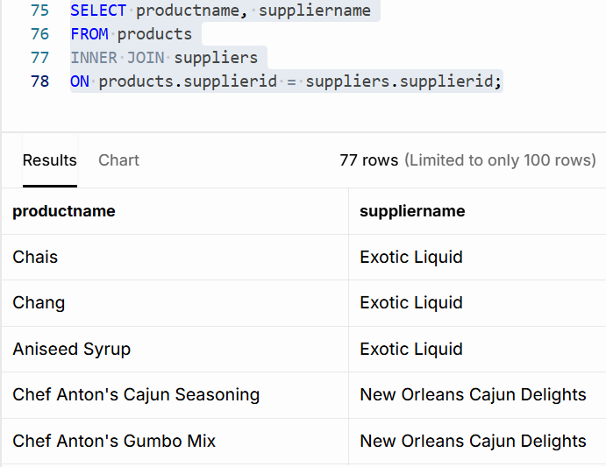

2. 📘 Classifying Products by Category
The category manager is reviewing how products are organized.
➡️ Write a SQL query to find the category of each product.
SELECT productname, categoryname
FROM products
INNER JOIN categories
ON products.categoryid = categories.categoryid;
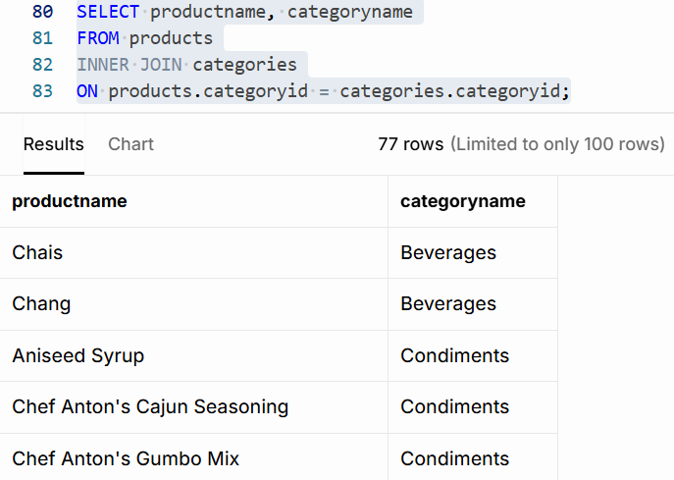

3.📘 Category-Specific Product Report: Meat/Poultry
The food department wants to view all items in the Meat/Poultry category.
➡️ Write a SQL query to retrieve all products belonging to the Meat/Poultry category.
SELECT productname
FROM products
INNER JOIN categories
ON products.categoryid = categories.categoryid
WHERE categoryname = 'Meat/Poultry';
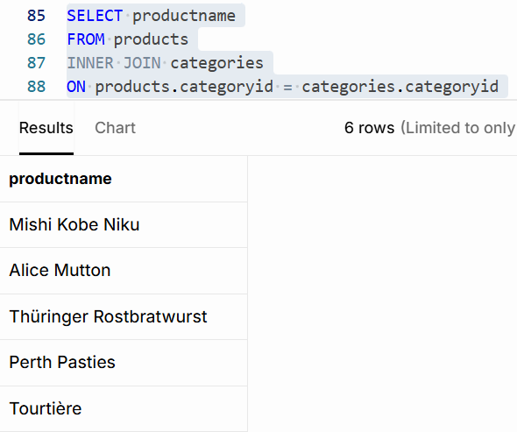

4.📘 Complete Order Overview
The business team wants to see a detailed order list with customer and employee information.
➡️ Write a SQL query to retrieve the Order ID, Order Date, Customer Name, and Employee Name for all orders.
SELECT orderid, orderdate, customername, firstname, lastname – there is no employeename, only firstname and lastname
FROM orders
INNER JOIN customers
ON orders.customerid = customers.customerid
INNER JOIN employees
ON orders.employeeid = employees.employeeid;
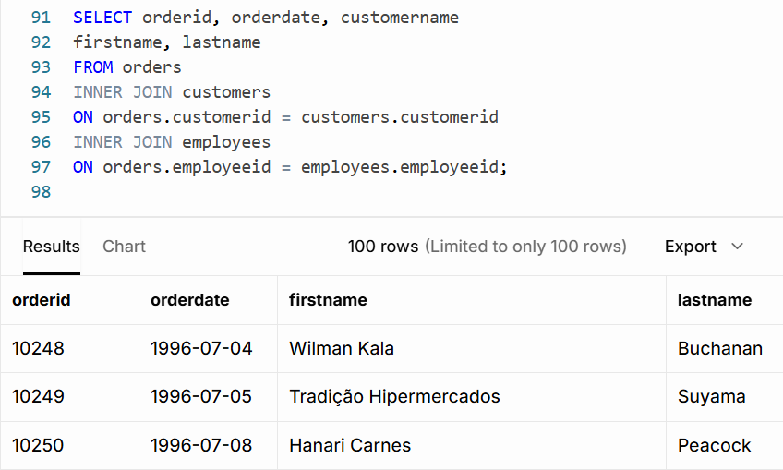

5.📘 Supply Chain Overview Report
Your manager wants to see the product name, its category, and the name of its supplier all in one report.
➡️ Write a SQL query to retrieve the Product Name, Category Name, and Supplier Name for all products.
SELECT productname, categoryname, suppliername
FROM products
INNER JOIN categories
ON products.categoryid = categories.categoryid
INNER JOIN suppliers
ON products.supplierid = suppliers.supplierid;
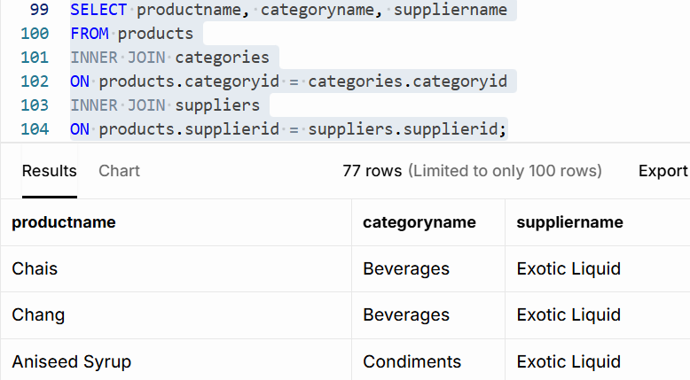

6.📘 Yearly Order Summary – 1996
The team is auditing customer orders made in 1996.
➡️ Write a SQL query to create a report for all the orders of 1996 and their customers.
SELECT orderid,
orderdate,
customername
FROM orders
INNER JOIN customers
ON orders.customerid = customers.customerid
WHERE EXTRACT(YEAR FROM orderdate) = 1996;
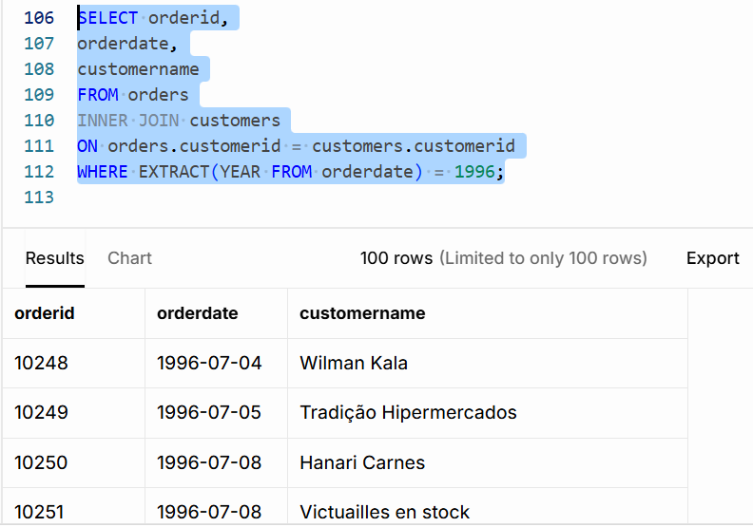

7.📘 Product Count by Category
The product team wants to know how many products exist under each category.
➡️ Write a SQL query to retrieve all categories along with the number of products in each category.
SELECT categoryname,
COUNT(productid) AS number_of_products
FROM categories
INNER JOIN products
ON categories.categoryid = products.categoryid
GROUP BY categoryname;
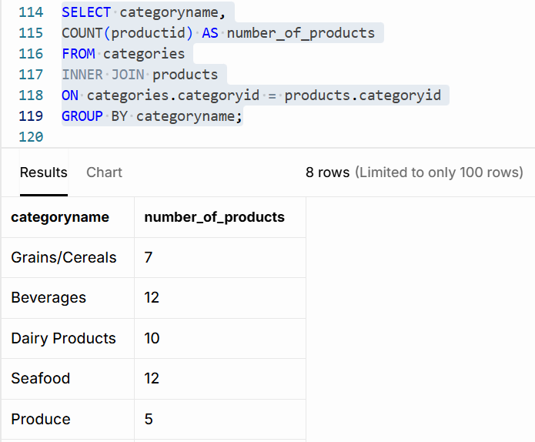

8.📘 Sales Volume Breakdown
The sales department wants to analyze how much of each product was ordered and at what price.
➡️ Write a SQL query to retrieve all products with their prices and the quantity ordered for each product.
SELECT productname, price, quantity
FROM products
INNER JOIN order_details
ON products.productid = order_details.productid;
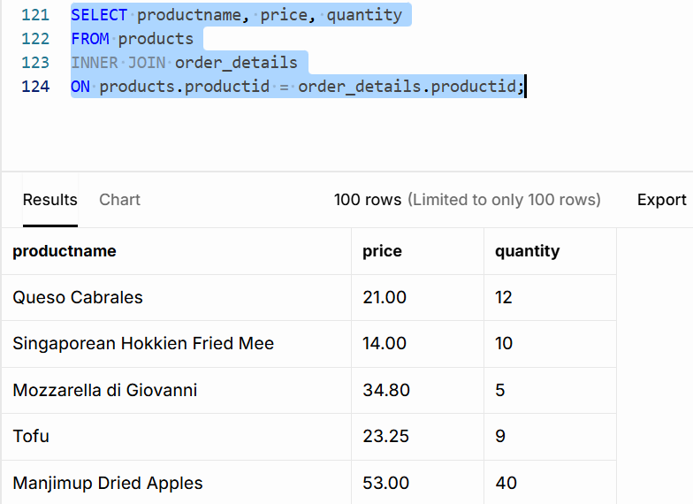

Day 4: Task 1: SQL Practical

You are working as a junior data analyst for an international research organization analysing countries, cities, and languages from around the world. Your job is to write and run SQL queries that provide useful global insights.
For each task:
- Write the appropriate SQL query to meet the scenario's objective.
- Run your query using MySQL Workbench and the world database.
- Take a screenshot that clearly shows both your SQL code and the result table.
- Paste the copy of your query in the box provided for each question as evidence of completion.
Setting up the database:

- Visit your Superbase profile
- Create a new project
- Open and copy SQL script here Create World DB on Supabase
- Go to SQL Editor and paste it on new query window.
- Go to Table editor and verify city, country and countrylanguage tables are created.
- You can also watch this video to create it. How to create World DB on Supabase.webm

- Count Cities in USA: Scenario: You've been tasked with conducting a demographic analysis of cities in the United States. Your first step is to determine the total number of cities within the country to provide a baseline for further analysis.

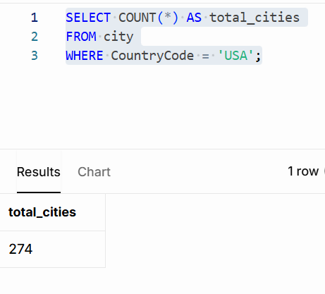

- Country with Highest Life Expectancy: Scenario: As part of a global health initiative, you've been assigned to identify the country with the highest life expectancy. This information will be crucial for prioritising healthcare resources and interventions.

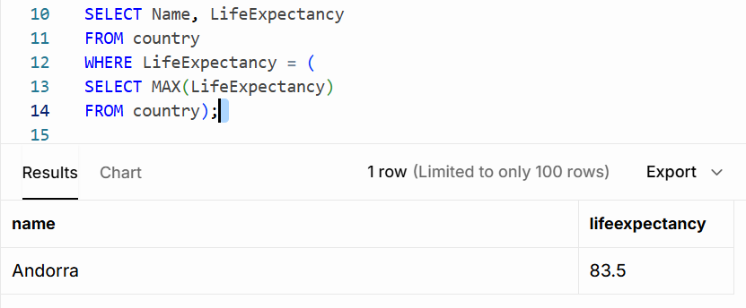

- "New Year Promotion: Featuring Cities with 'New : Scenario: In anticipation of the upcoming New Year, your travel agency is gearing up for a special promotion featuring cities with names including the word 'New'. You're tasked with swiftly compiling a list of all cities from around the world. This curated selection will be essential in creating promotional materials and enticing travellers with exciting destinations to kick off the New Year in style.
If only city:
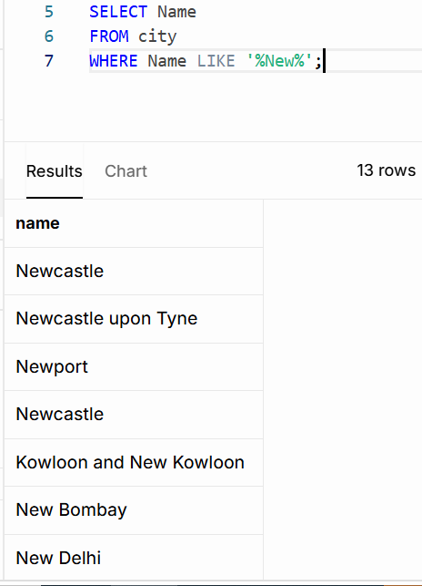

If the country’s names are also included:
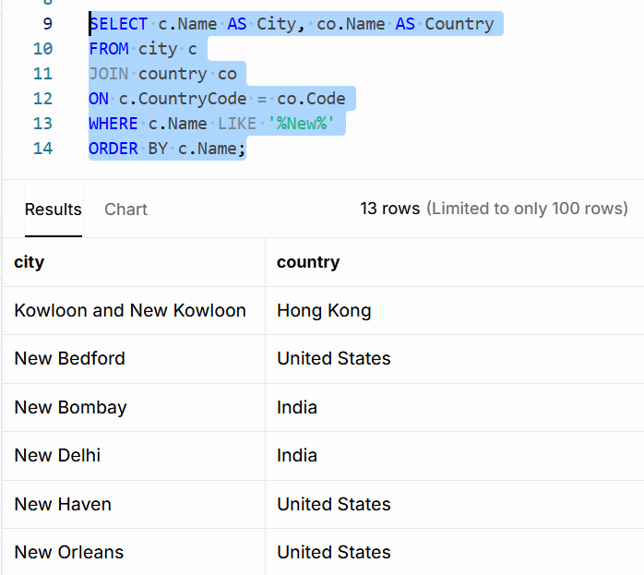

- Display Columns with Limit (First 10 Rows): Scenario: You're tasked with providing a brief overview of the most populous cities in the world. To keep the report concise, you're instructed to list only the first 10 cities by population from the database.
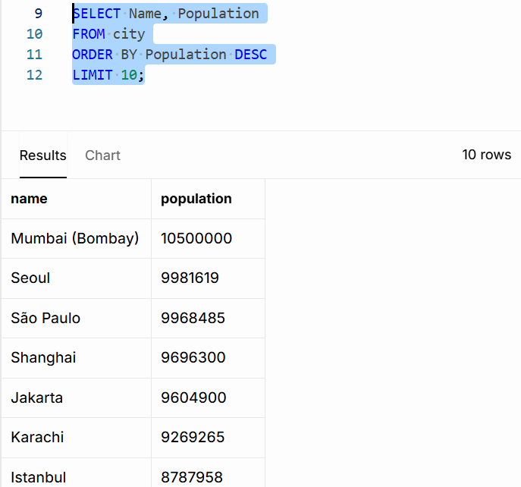

- Cities with Population Larger than 2,000,000: Scenario: A real estate developer is interested in cities with substantial population sizes for potential investment opportunities. You're tasked with identifying cities from the database with populations exceeding 2 million to focus their research efforts.

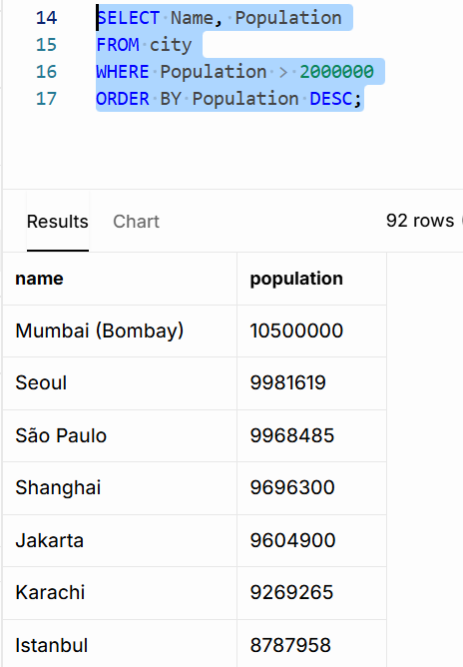

- Cities Beginning with 'Be' Prefix: Scenario: A travel blogger is planning a series of articles featuring cities with unique names. You're tasked with compiling a list of cities from the database that start with the prefix 'Be' to assist in the blogger's content creation process.
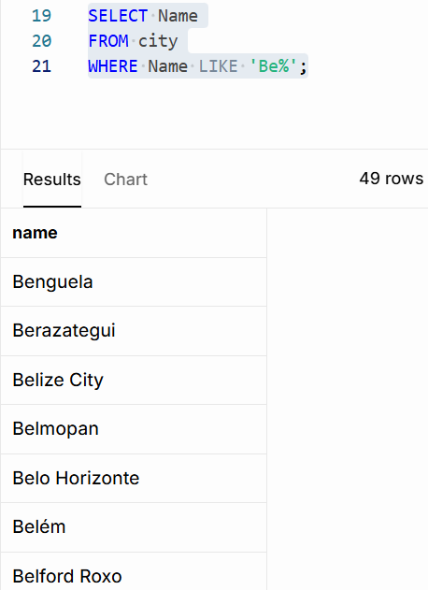

- Cities with Population Between 500,000-1,000,000: Scenario: An urban planning committee needs to identify mid-sized cities suitable for infrastructure development projects. You're tasked with identifying cities with populations ranging between 500,000 and 1 million to inform their decision-making process.
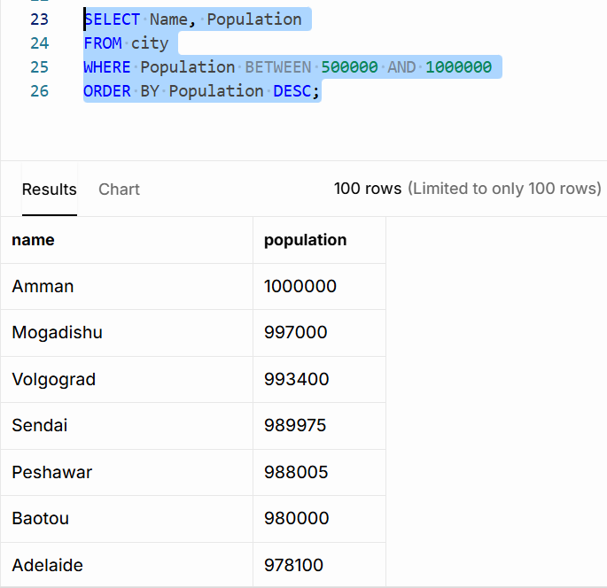

- Display Cities Sorted by Name in Ascending Order: Scenario: A geography teacher is preparing a lesson on alphabetical order using city names. You're tasked with providing a sorted list of cities from the database in ascending order by name to support the lesson plan.
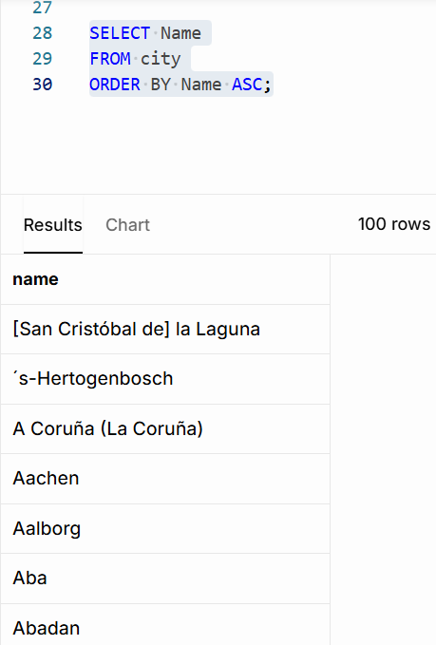

- Most Populated City: Scenario: A real estate investment firm is interested in cities with significant population densities for potential development projects. You're tasked with identifying the most populated city from the database to guide their investment decisions and strategic planning.
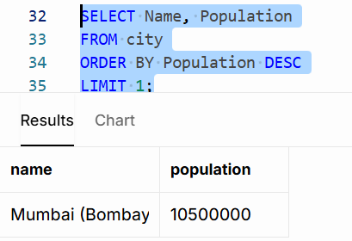

- City Name Frequency Analysis: Supporting Geography Education Scenario: In a geography class, students are learning about the distribution of city names around the world. The teacher, in preparation for a lesson on city name frequencies, wants to provide students with a list of unique city names sorted alphabetically, along with their respective counts of occurrences in the database. You're tasked with this sorted list to support the geography teacher.
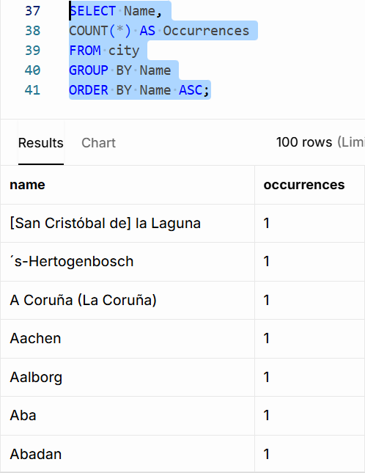

- City with the Lowest Population: Scenario: A census bureau is conducting an analysis of urban population distribution. You're tasked with identifying the city with the lowest population from the database to provide a comprehensive overview of demographic trends.
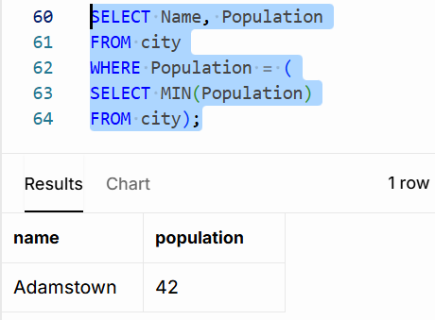

- Country with Largest Population: Scenario: A global economic research institute requires data on countries with the largest populations for a comprehensive analysis. You're tasked with identifying the country with the highest population from the database to provide valuable insights into demographic trends.
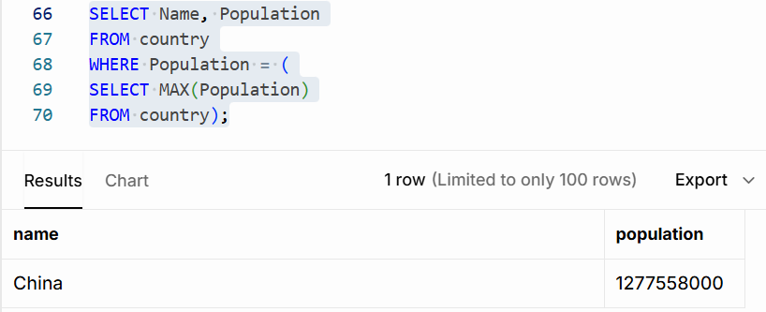

- Capital of Spain: Scenario: A travel agency is organising tours across Europe and needs accurate information on capital cities. You're tasked with identifying the capital of Spain from the database to ensure itinerary accuracy and provide travellers with essential destination information.
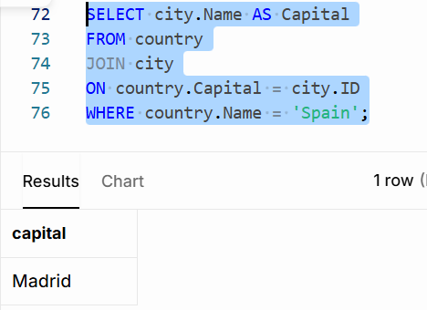

- Cities in Europe: Scenario: A European cultural exchange program is seeking to connect students with cities across the continent. You're tasked with compiling a list of cities located in Europe from the database to facilitate program planning and student engagement.
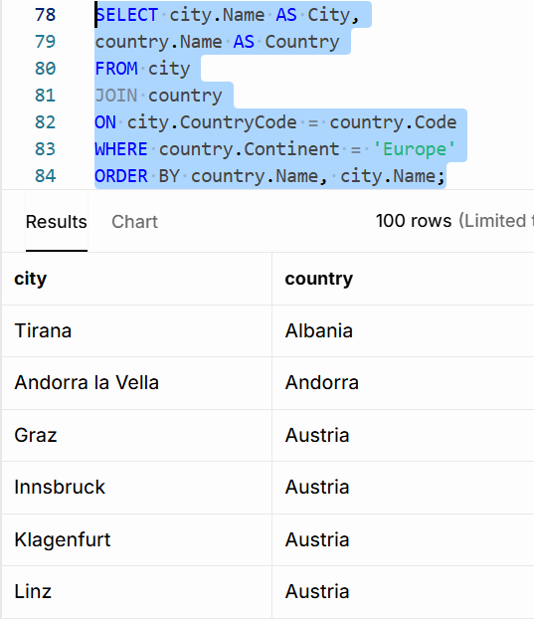

- Average Population by Country: Scenario: A demographic research team is conducting a comparative analysis of population distributions across countries. You're tasked with calculating the average population for each country from the database to provide valuable insights into global population trends.
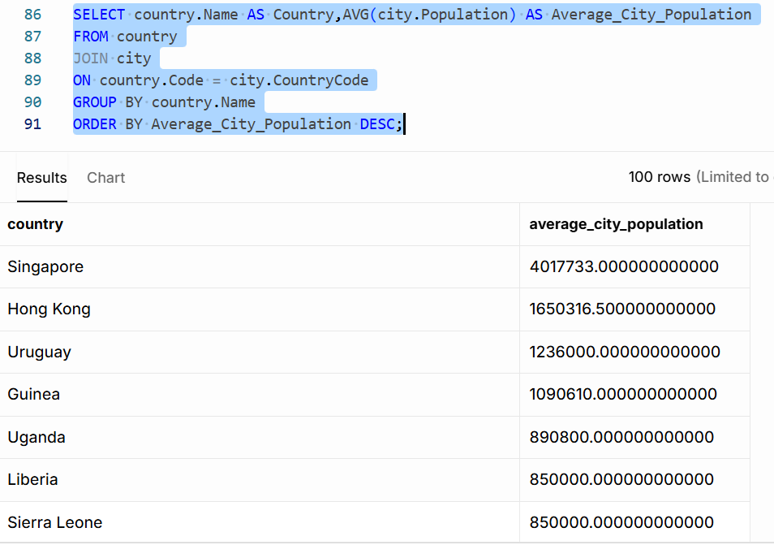

- Capital Cities Population Comparison: Scenario: A statistical analysis firm is examining population distributions between capital cities worldwide. You're tasked with comparing the populations of capital cities from different countries to identify trends and patterns in urban demographics.
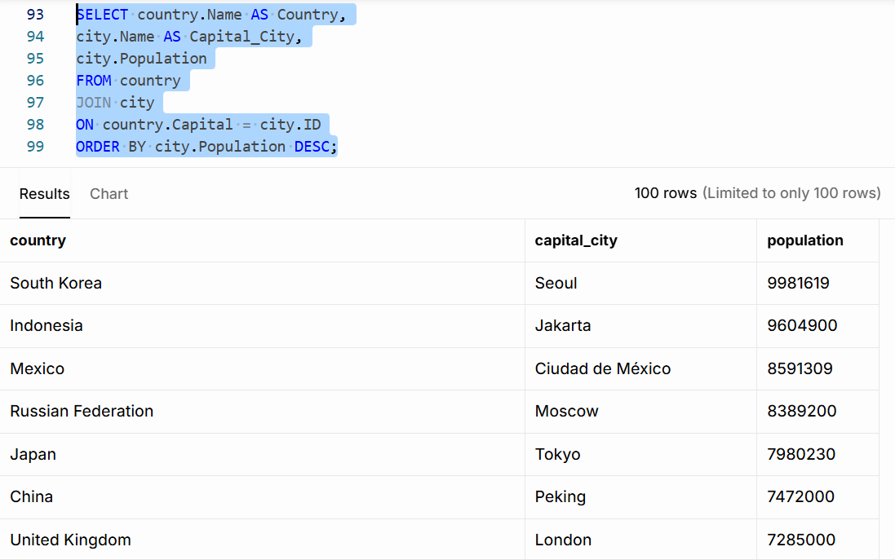

- Countries with Low Population Density: Scenario: An agricultural research institute is studying countries with low population densities for potential agricultural development projects. You're tasked with identifying countries with sparse populations from the database to support the institute's research efforts.
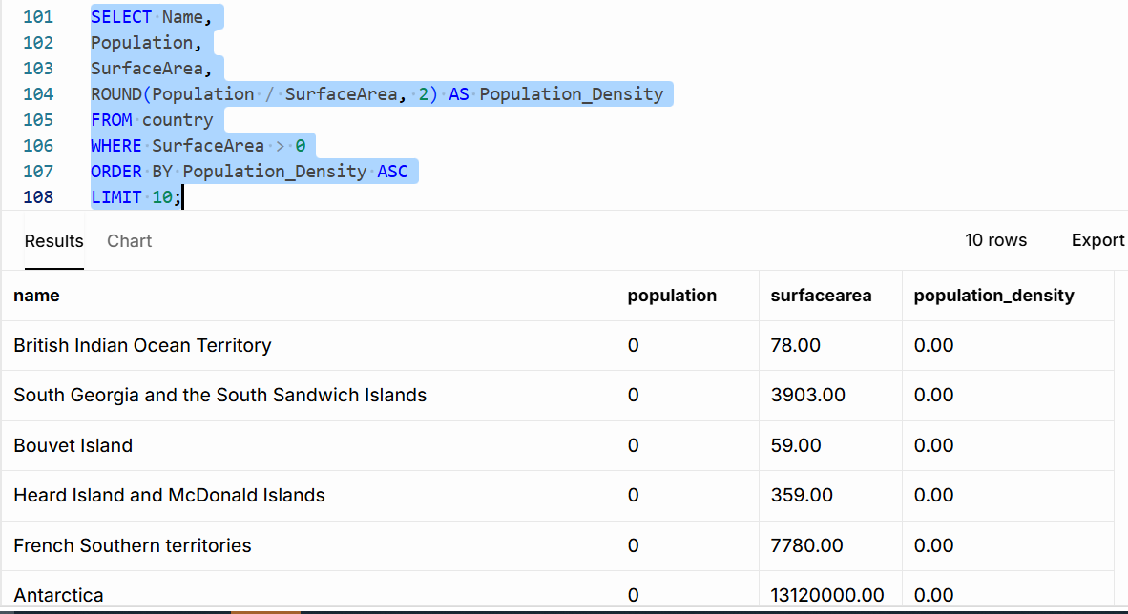

- Display Columns with Limit (Rows 31-40): Scenario: A market research firm requires detailed information on cities beyond the top rankings for a comprehensive analysis. You're tasked with providing data on cities ranked between 31st and 40th by population to ensure a thorough understanding of urban demographics.
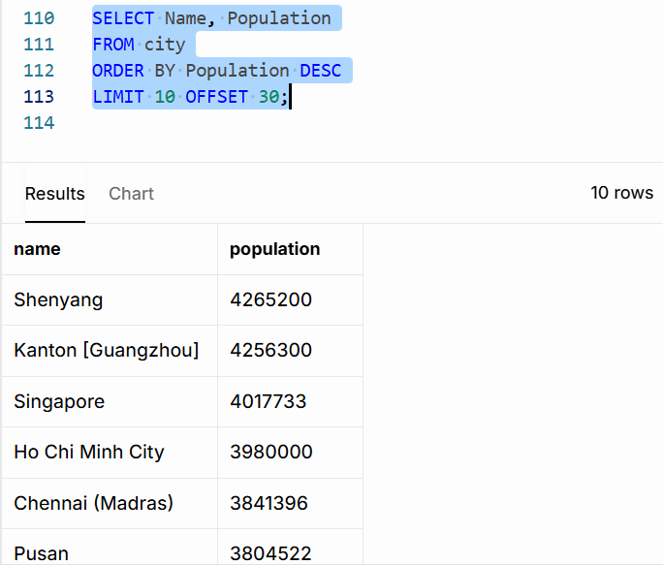

Additional Resources
- DataCamp Recommended Courses
- Introduction to SQL - DataCamp Learn
- Intermediate SQL - DataCamp Learn
- Joining Data in SQL - DataCamp Learn

- SQLBolt - Learn SQL - Introduction to SQL : Welcome to SQLBolt, a series of interactive lessons and exercises designed to help you quickly learn SQL right in your browser.

- MySQL Tutorial: Tutorial website.

- MySQL Basics Tutorial Series - YouTube: MySQL Basics Tutorial Series

- Hackerrank Challenges: How to use hackerrank challanges.odt

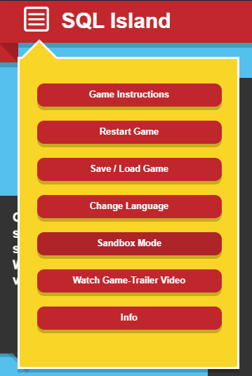
- SQL Island: After the survived plane crash, you will be stuck on SQL Island for the time being. By making progress in the game, you will find a way to escape from this island.
Change Language to English.

Course Notes

It is recommended to take notes from the course, use the space below to do so, or use the revision guide shared with the class:

We have included a range of additional links to further resources and information that you may find useful, these can be found within your revision guide.

END OF WORKBOOK

Please check through your work thoroughly before submitting and update the table of contents if required.

Please hand in your workbook in MS Assignment page.

